*Term Project*

*Instructor: Faisal Khan*

|  |  |  |
| --- | --- | --- |
| *Name* | *Student ID* | *Group#* |
| ***Sakshi Jain*** | ***C0753352*** |  |
| ***Jugdeep Kaur*** | ***C0753604*** |  |
| ***Shagun Sharma*** | ***C0752970*** |  |
|  |  |  |

1-Use Documentation Comments where needed and use Javadoc to create HTML files for documentation.

2-In your project src folder add this word document with all your group members names and paste the screen shots of your output after each question.

3-Right Click on your Project Folder in Eclipse, Copy Option is available. Create a copy of the Project and upload the zipped folder using Moodle.

Create a web based application using Either JSF or JSPs & Servlets in BootStrap. Your web application should maintain

A Public Library User Records. You can use a model class

Library_User with fields like.

**User_ID,Name,Contact,Book_Issued,Date_Issued,Date_Returned.**

You should be able to perform all these CRUD Operations.

a)Create a Database LibraryRecords for your application.

Create a table named Library_Users in this database.

Insert 5 to 6 Records in this table.

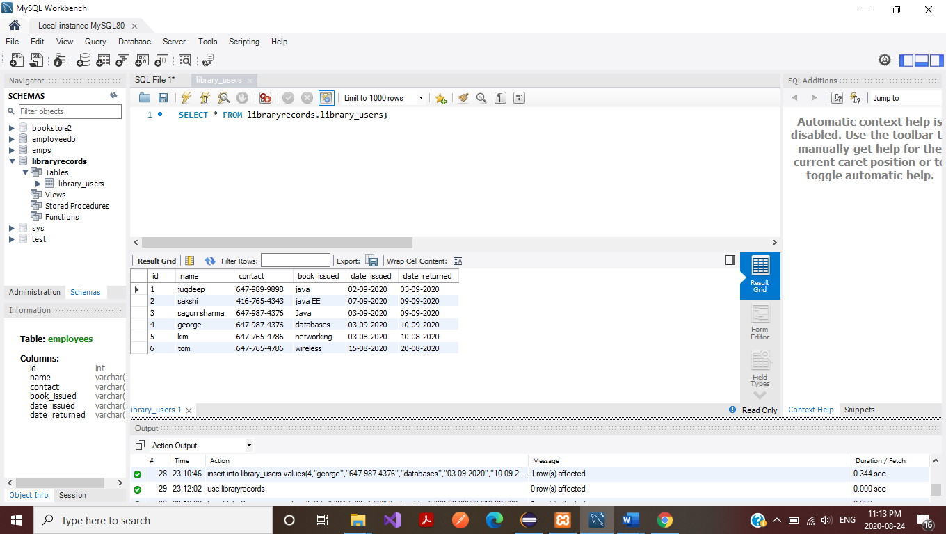

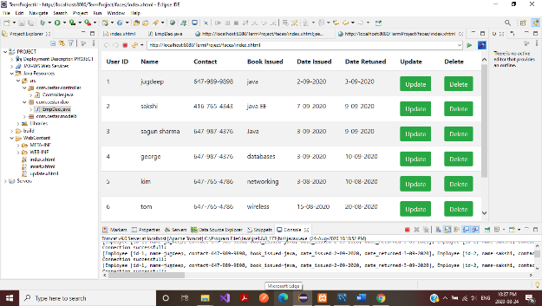 10

b) Display all the User Records in your xhtml page View or a JSP page as a table.

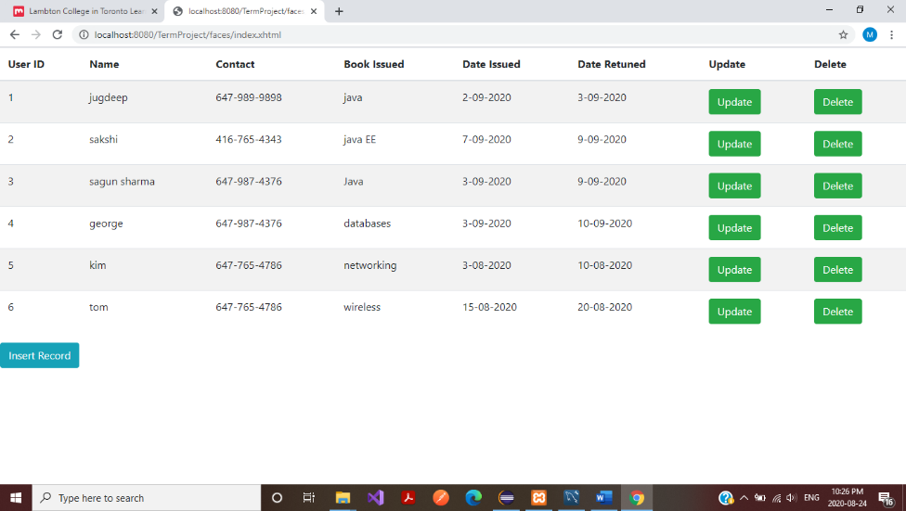

c) Add a new User Record in to the database using a button on your view page. 20

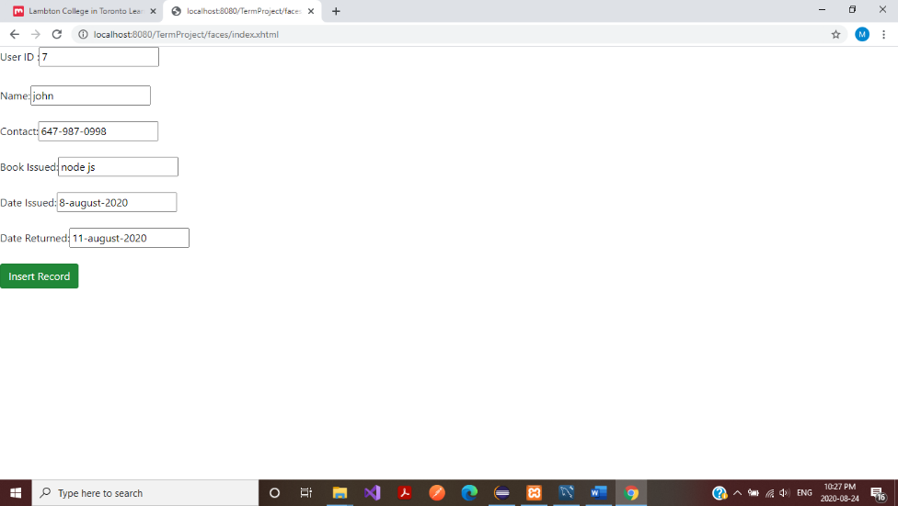

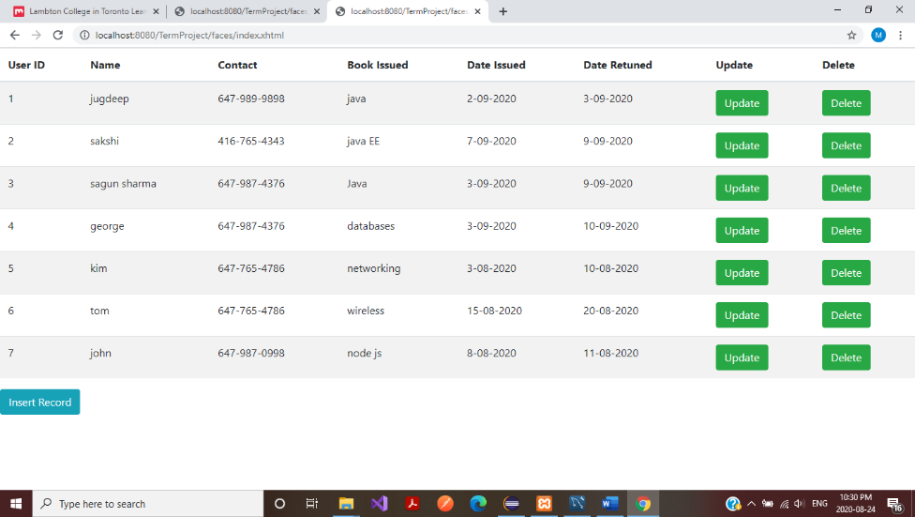

d)Update an existing User Record using an Update Button on your view page.

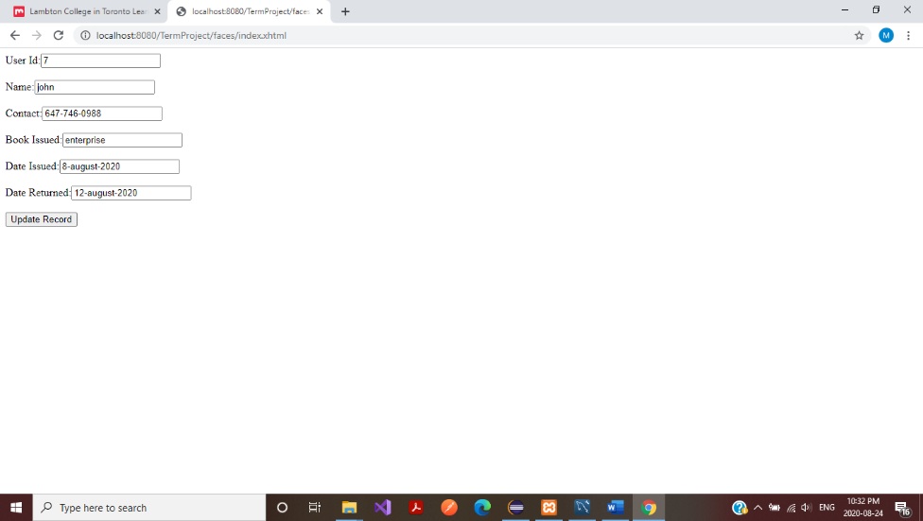

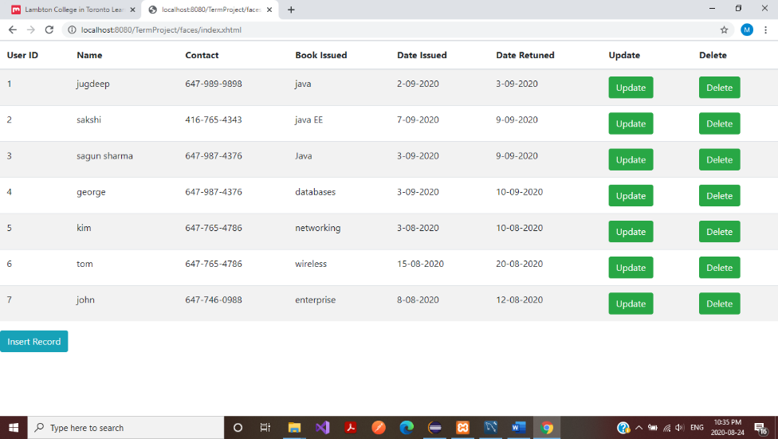

e)Delete a User Record using a Delete Button on your view page. 20

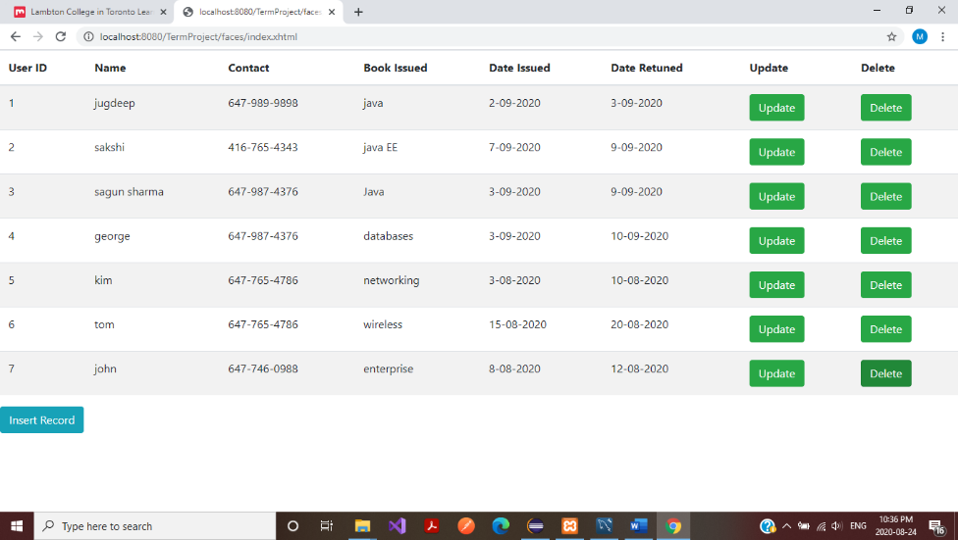

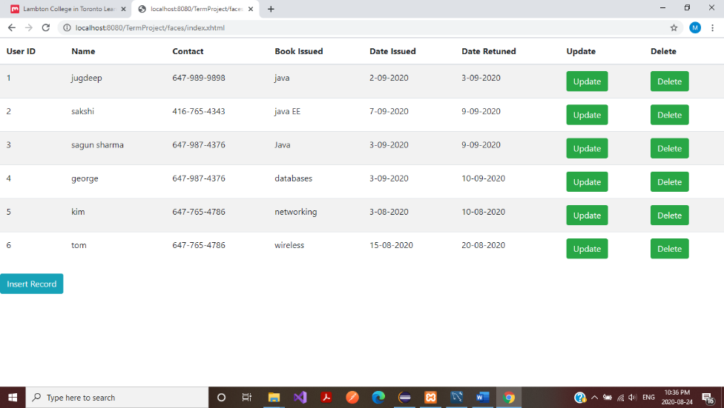

f) Use ManagedBean if using JSF with annotation and create separate DAO class for Crud operations or use a Simple Java Bean as your Model class if using JSPs and Servlets.Try to create separate methods for all crud operations. 10

